PROJECT DEVELOPMENT PHASE
DATE: | 27/09/2026
TEAM ID: | SWTID-2026-6463
PROJECT NAME: | AI FAQ Assistant API
MAXIMUM MARKS: | 5Marks

Objectiv
Implement the core features of the Al FAQ Assistant API by writing backend logic, integrating Gemini AI, connecting MongoDB, and building secure APIs for user authentication, FAQ management, semantic search and Al answer generation.

Key Development Tasks

- Set up Node.js and Express.js project structure.

- Implement user authentication with JWT and bcrypt.

- Create MongoDB models (User, FAQ, Chat, etc.).

- Develop API routes (register, login, create FAQ, search, Al answer).

- Integrate Google Gemini Al for generating answers and suggestions.

- Implement semantic search and context parsing.

- Add error handling and response sanitization.

- Test all endpoints using Postman / Thunder Client.

Expected Outcome

- Working REST API with authentication and route guarding.

- Al-powered FAQ creation, search and answer generation.

- Data stored securely in MongoDB.

- Ready for frontend integration

SYSTEM ARCHITECTURE/FLOW:
MONGODB
NODE.JS+
EXPRESS.JS
GEMINI AI
USER

Project Folder Structure:
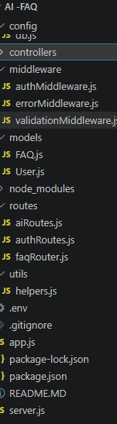
DEVELOPMENT ENIRONMENT:
- NODE.JS = V18+
- EXPRESS.JS=V5.1.0
- MONGODB=V6+/COMPASS
- GOOGLE GEMINI=GEMINI-3.5-FLASH
- JWT=V9.0.2
- Bcrypt=v3.0.0

